**FACTORIAL OF A GIVEN NUMBER**

**EXP NO: 9**

**AIM:** To find the factorial of a given number using 8085 microprocessor.

**ALGORITHM:**

1. Load the data into register B
2. To start multiplication set D to 01H
3. Jump to step 7
4. Decrements B to multiply previous number
5. Jump to step 3 till value of B>0
6. Take memory pointer to next location and store result
7. Load E with contents of B and clear accumulator
8. Repeatedly add contents of D to accumulator E times
9. Store accumulator content to D
10. Go to step 4

**PROGRAM:**

LDA 2001

MOV B,A

MVI C,#01

MVI E,#01

LOOP: MOV D,C

MVI A,00H

LP: ADD E

DCR D

JNZ LP

MOV E,A

INR C

DCR B

JNZ LOOP

MOV A,E

STA 2010

HLT

**INPUT:**

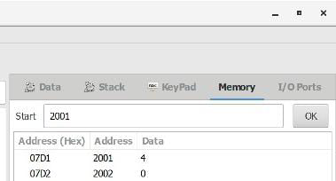

**OUTPUT:**

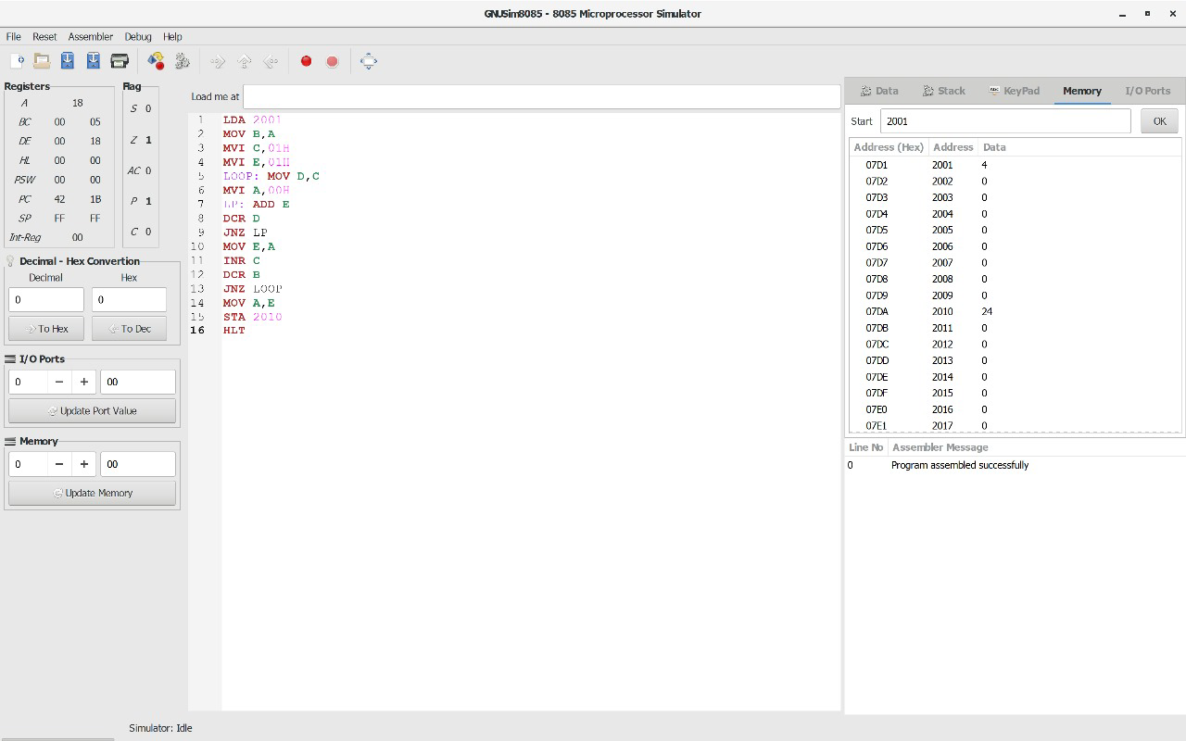

**RESULT:** Thus the program was executed successfully using 8085 processor simulator.

**LARGEST NUMBER IN AN ARRAY**

**EXP NO: 10**

**AIM:** To find the largest number from an array using 8085 processor.

**ALGORITHM:**

1. Load the address of the first element of the array in HL pair.
2. Move the count to B register.
3. Increment the pointer.
4. Get the first data in A register.
5. Decrement the count.
6. Increment the pointer.
7. Compare the content of memory addressed by HL pair with that of A register.
8. If carry=0, go to step 10 or if carry=1 go to step 9
9. Move the content of memory addressed by HL to A register.
10. Decrement the count.

**PROGRAM:**

LXI H,2050

MOV C,M

DCR C

INX H

MOV A,M

LOOP1: INX H

CMP M

JNC LOOP

MOV A,M

LOOP: DCR C

JNZ LOOP1

STA 2058

HLT

**INPUT:**

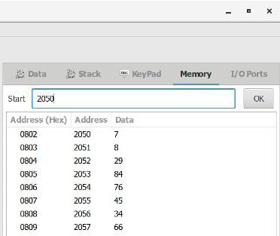

**OUTPUT:**

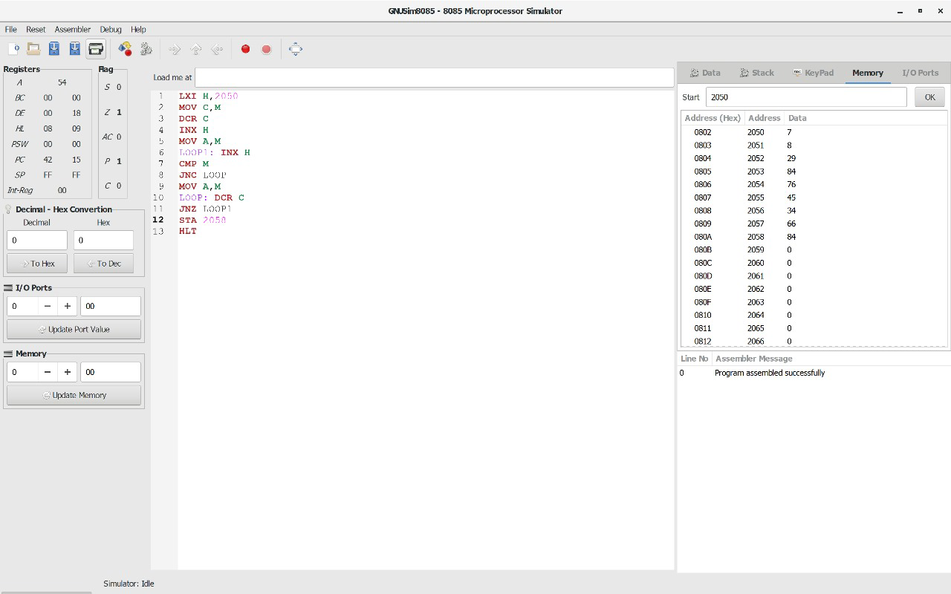

**RESULT:** Thus the program was executed successfully using 8086 processor simulator.

**SMALLEST NUMBER IN AN ARRAY**

**EXP NO: 11**

**AIM:** To find the smallest number from an array using 8085 processor.

**ALGORITHM:**

1. Load the address of the first element of the array in HL pair.
2. Move the count to B register.
3. Increment the pointer.
4. Get the first data in A register.
5. Decrement the count.
6. Increment the pointer.
7. Compare the content of memory addressed by HL pair with that of A register.
8. If carry=1, go to step 10 or if carry=0 go to step 9
9. Move the content of memory addressed by HL to A register.
10. Decrement the count.

**PROGRAM:**

LXI H,2050

MOV C,M

DCR C

INX H

MOV A,M

LOOP1: INX H

CMP M

JC LOOP

MOV A,M

LOOP: DCR C

JNZ LOOP1

STA 2058

HLT

**INPUT:**



**OUTPUT:**

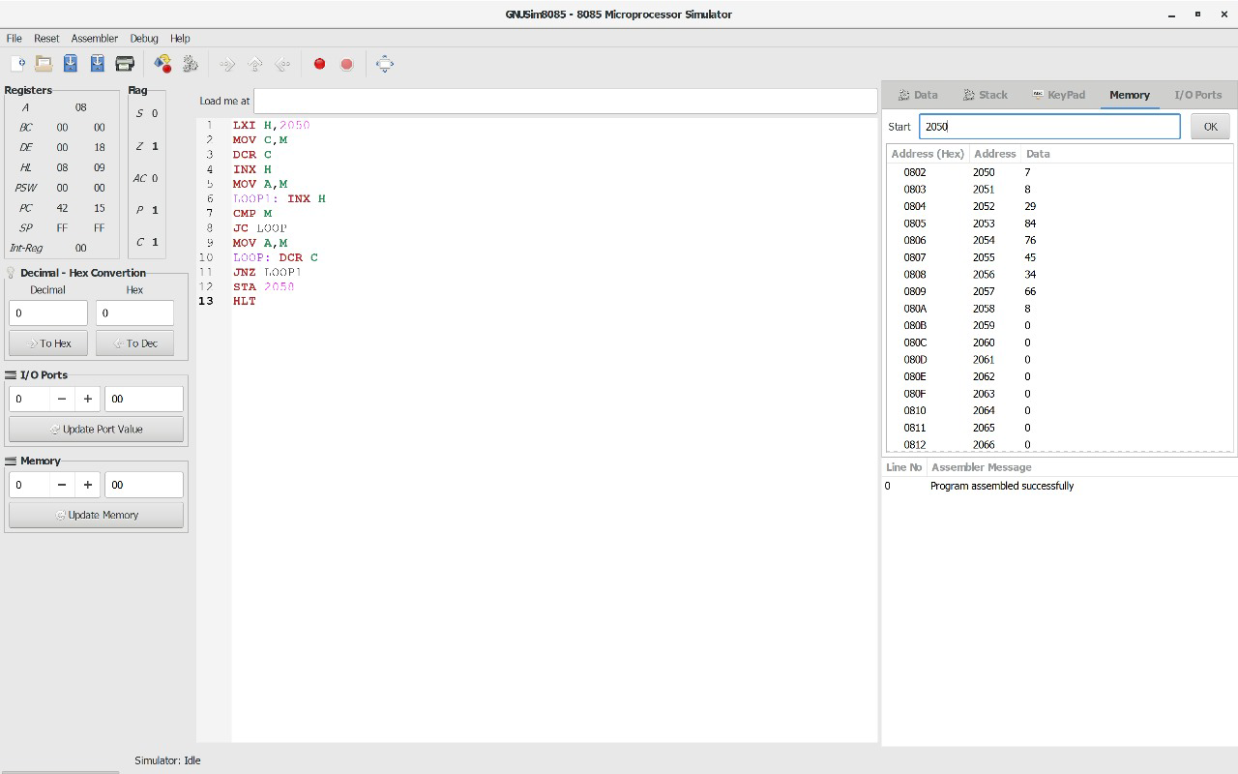

**RESULT:** Thus the program was executed successfully using 8085 processor simulator.

**ASCENDING ORDER**

**EXP NO: 12**

**AIM:** To compute ascending order of an array using 8085 processor.

**ALGORITHM:**

1. Initialize HL pair as memory pointer.
2. Get the count at memory and load it into C register
3. Copy it in D register (for bubble sort (N-1)) times required).
4. Get the first value in A register.
5. Compare it with the value at next location.
6. If they are out of order, exchange the contents of A register and memory.
7. Decrement D register content by 1
8. Repeat step 5 and 7 till the value in D register become zero.
9. Decrement the C register content by 1.
10. Repeat steps 3 to 9 till the value in C register becomes zero.

**PROGRAM:**

LOOP: LXI H,3500

MVI D,00

MVI C,05

LOOP1: MOV A,M

INX H

CMP M

JC LOOP2

MOV B,M

MOV M,A

DCX H

MOV M,B

INX H

MVI D,01

LOOP2: DCR C

JNZ LOOP1

MOV A,D

RRC

JC LOOP

HLT

**INPUT:**

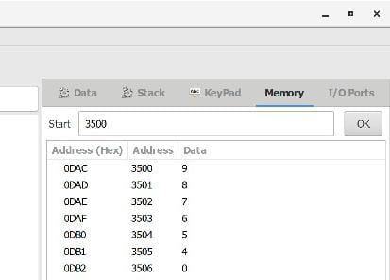

**OUTPUT:**

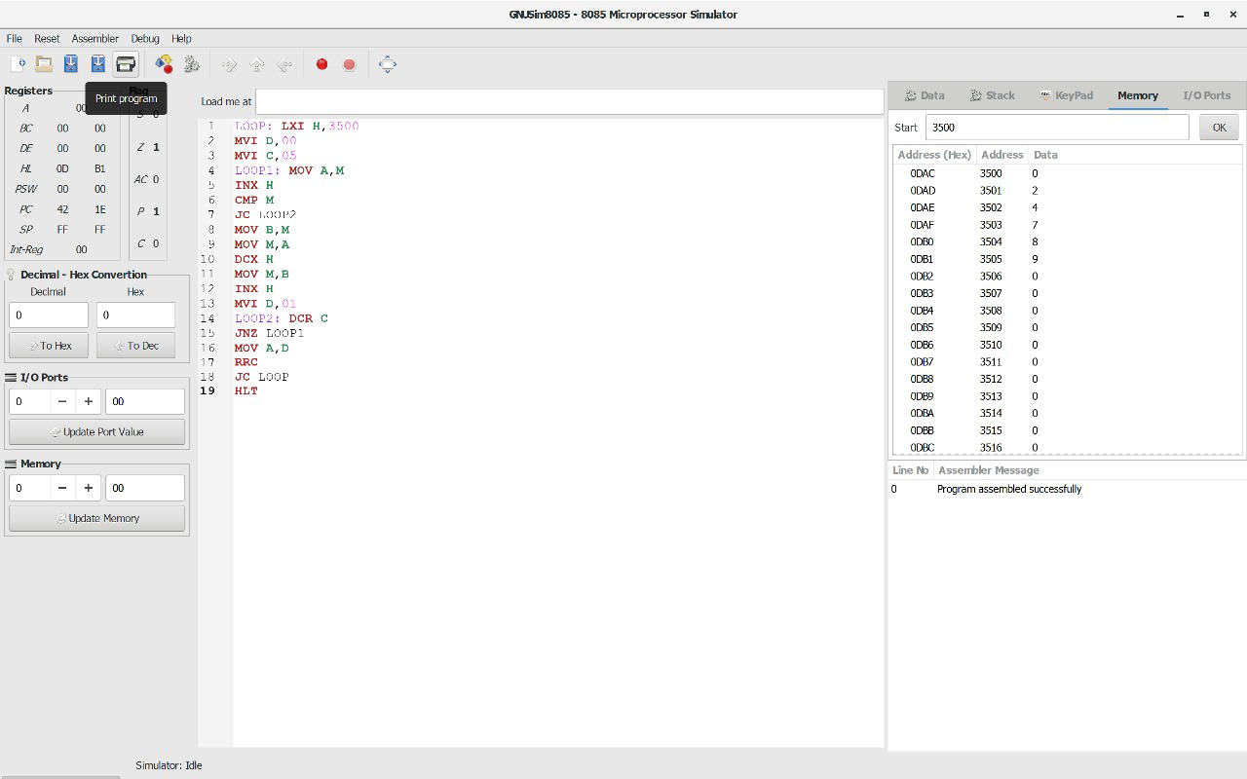

**RESULT:** Thus the program was executed successfully using 8085 processor simulator.

**DESCENDING ORDER**

**EXP NO: 13**

**AIM:** To compute descending order of an array using 8085 processor.

**ALGORITHM:**

1. Initialize HL pair as memory pointer.
2. Get the count at memory and load it into C register
3. Copy it in D register (for bubble sort (N-1)) times required).
4. Get the first value in A register.
5. Compare it with the value at next location.
6. If they are out of order, exchange the contents of A register and memory.
7. Decrement D register content by 1
8. Repeat step 5 and 7 till the value in D register become zero.
9. Decrement the C register content by 1.
10. Repeat steps 3 to 9 till the value in C register becomes zero.

**PROGRAM:**

LOOP: LXI H,3500

MVI D,00

MVI C,05

LOOP1: MOV A,M

INX H

CMP M

JNC LOOP2

MOV B,M

MOV M,A

DCX H

MOV M,B

INX H

MVI D,01

LOOP2: DCR C

JNZ LOOP1

MOV A,D

RRC

JC LOOP

HLT

**INPUT:**

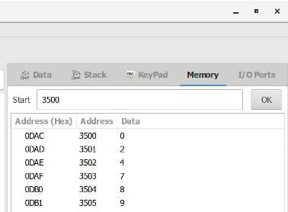

**OUTPUT:**

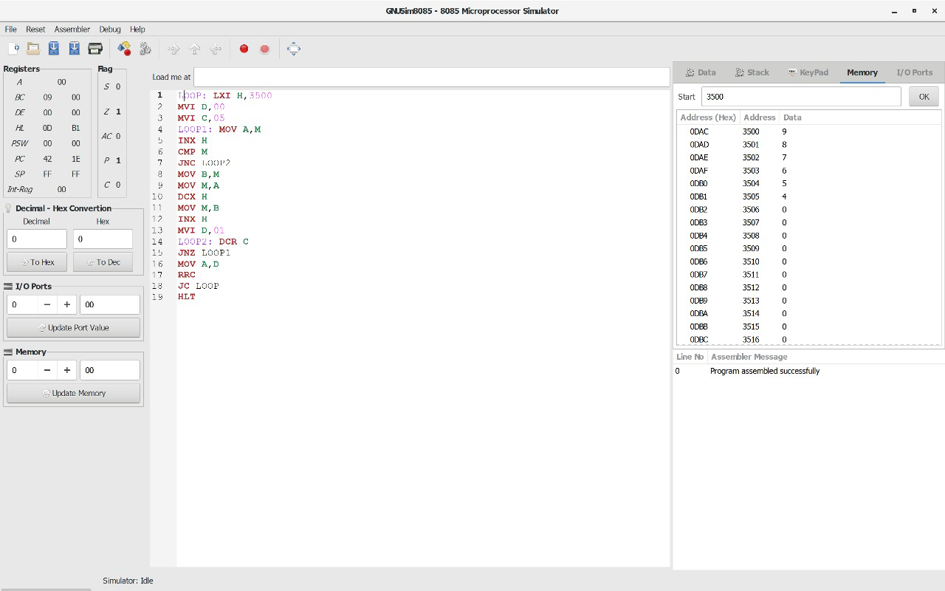

**RESULT:** Thus the program was executed successfully using 8085 processor simulator.

**ADDITION OF N NUMBERS**

**EXP NO: 14**

**AIM:** To compute addition of N numbers using 8085 processor.

**ALGORITHM:**

1. Load the base address of the array in HL register pair.
2. Load the memory with data to be added.
3. Take it as count.
4. Initialize the accumulator with 00.
5. Add content of accumulator with content of memory.
6. Decrement count.
7. Load count value to memory location.
8. Repeat step 5.
9. Check whether count has become 0.
10. Halt.

**PROGRAM:**

LXI H,8000

MOV C,M

MVI A,00

MOV B,A

LOOP: ADD C

JNC SKIP

INR B

SKIP: DCR C

JNZ LOOP

LXI H,8007

MOV M,A

INX H

MOV M,B

HLT

**INPUT:**

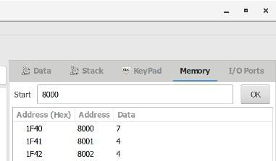

**OUTPUT:**

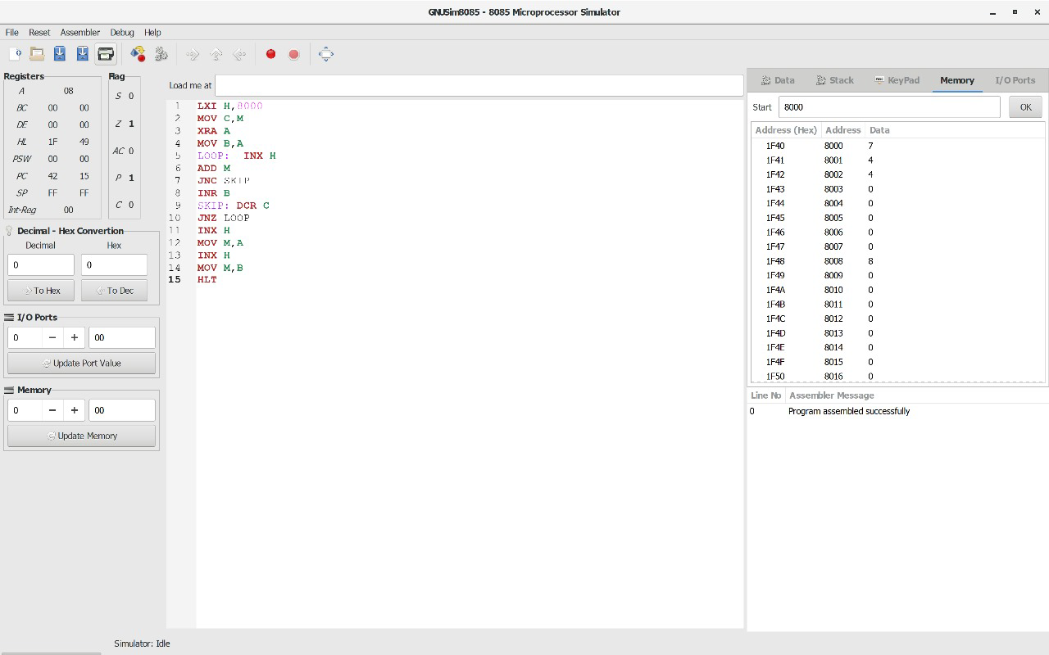

**RESULT:** Thus the program was executed successfully using 8085 processor simulator.

**SWAPPING OF NUMBERS**

**EXP NO: 15**

**AIM:** To compute swapping of numbers using 8085 processor.

**ALGORITHM:**

1. Load a 8-bit number from memory location into accumulator.
2. Move value of accumulator into register H.
3. Load a 8-bit number from next memory location into accumulator.
4. Move value of accumulator into register D.
5. Exchange both the registers pairs.
6. Halt

**PROGRAM:**

LDA 2001

MOV B,A

LDA 2002

MOV C,A

STA 2003

MOV A,B

STA 2004

HLT

**INPUT:**

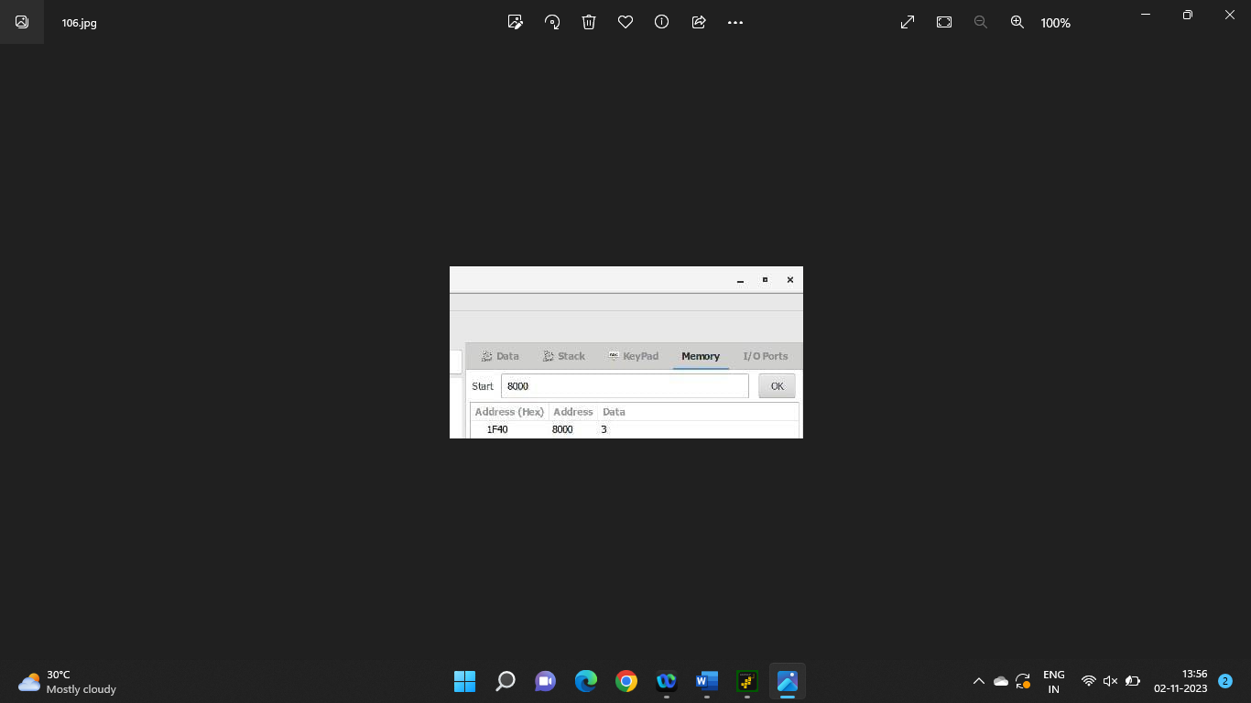

**OUTPUT:**

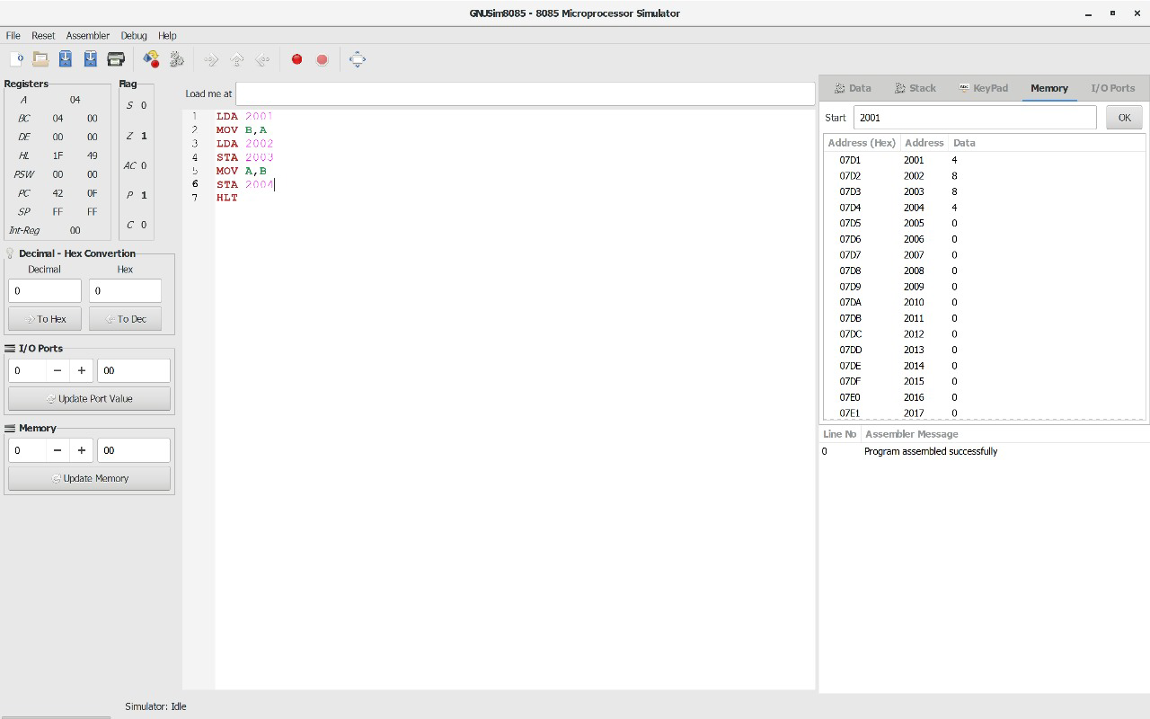

**RESULT:** Thus the program was executed successfully using 8085 processor simulator.

**SQUARE OF NUMBER**

**EXP NO: 16**

**AIM:** To compute square of number using 8085 processor.

**ALGORITHM:**

1. Load the base address of the array in HL register pair.
2. Assign accumulator as 0.
3. Load the content of memory location specified into register.
4. Add content of memory location with accumulator and decrement register content by 01.
5. Check if register holds 00, if so store the value of accumulator in memory location.

**PROGRAM:**

LXI H,8000

XRA A

MOV B,M

LOOP: ADD M

DCR B

JNZ LOOP

STA 8001

HLT

**INPUT:**

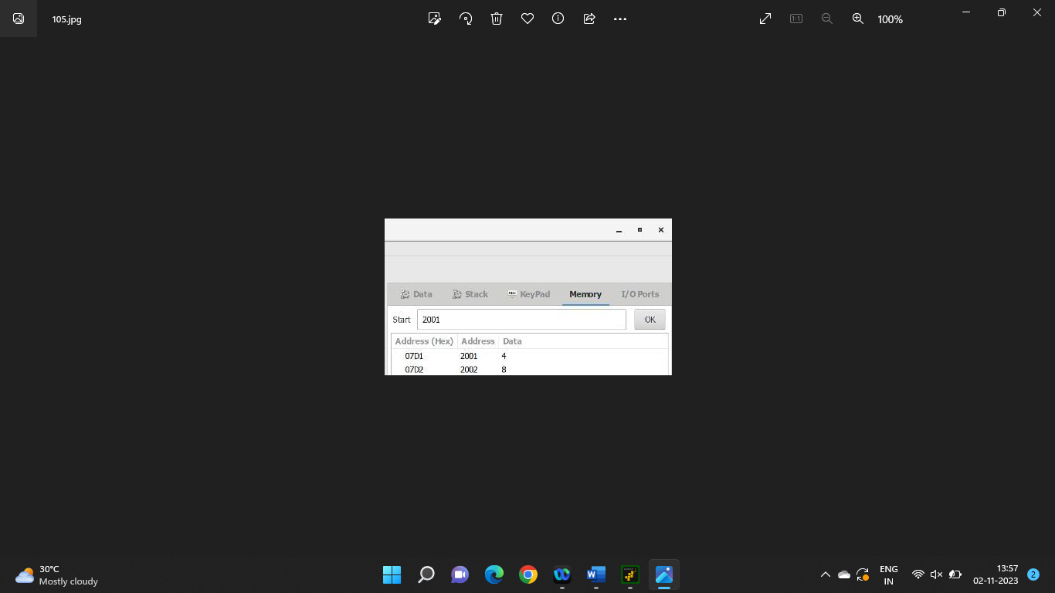

**OUTPUT:**



**RESULT:** Thus the program was executed successfully using 8085 processor simulator.